Dessinez une carte pour votre café! You are preparing to open your café in Paris and your last step is designing your menu. You need to have 4 categories-Entrées/Sandwichs/Boissons/Desserts. Think about how much you want to charge for each item, then google exchange rate, type in the amount in dollars and convert to euros. Be creative and add color and visual interest!



[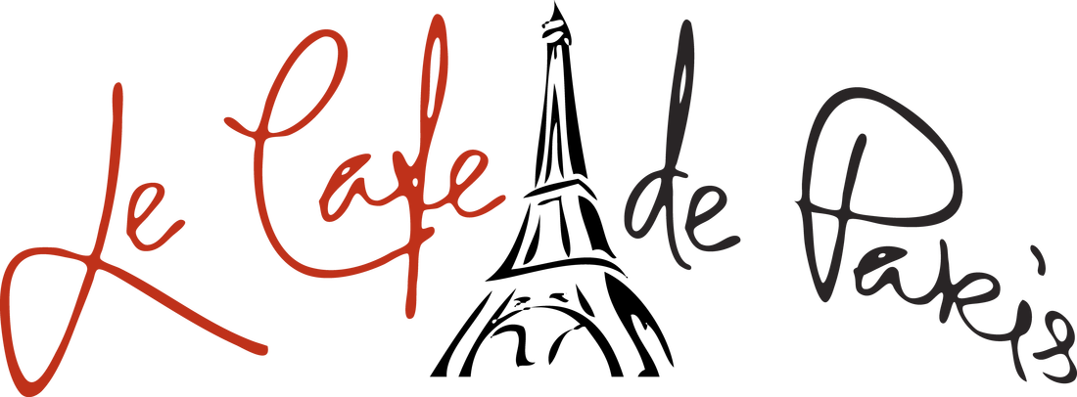](https://www.google.com/url?sa=i&rct=j&q=&esrc=s&source=images&cd=&cad=rja&uact=8&ved=2ahUKEwit76PNvtraAhVEGt8KHTK2BXcQjRx6BAgAEAU&url=http://www.shopcafeparis.com/about-us.html&psig=AOvVaw3pn_BEK9ruymz0YIA5AzGw&ust=1524919666466690)

