- Download the seesaw app on your phone from the playstore (it’s free)
- It will prompt you to link it to your email and put in the student code, see below:
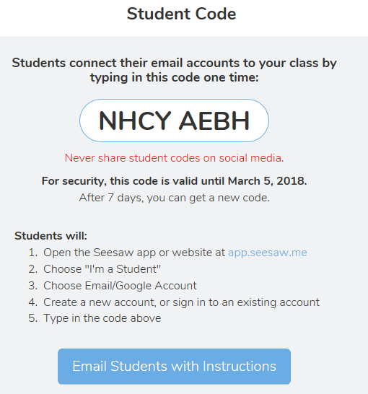
- Once you are in, click on activities and you will see the directions for the speaking assessment for unit 3. Make sure you use the video feature to record your response.
- This is due by Thurs.

